Supermarket Sales Analysis and Forecasting

Below you will find some analysis I have conducted on 3 months of Supermarket Sales. I used the supermarket sales dataset found on [kaggle](https://www.kaggle.com/aungpyaeap/supermarket-sales). For this analysis, the coding was done in Python, and I leveraged Facebooks’ Prophet forecasting module to forecast future sales of each of the Supermarkets three branches: Chicago, Denver, and Boston and data visualizations and tables were created in Power BI. My code can be found by navigating to my personal Github here

**Sales Analysis**

Overall, when analyzing all three branches of this supermarket, all branches averaged around $1,228 in daily sales. When breaking it down by each branch, the Boston branch averaged $1,193 in daily sales, the Denver branch averaged $1,234 in daily sales, and the Chicago branch averaged $1,256 in daily sales. It appears that the Denver and Chicago branches perform better than the daily average of branch sales ($1,228) while the Boston branch is below the daily sales average ($1,193), with the Chicago branch as the best performing branch of the three. You can see all charts by navigate to the appendix at the end of this report.

**Product Performance Analysis**

Of all the products this supermarket sales, most come from Food and Beverages, which accounts for 17.38% or over %56,000 in gross income.

The above table shows a break-down of sales by product lines for each branch as well as a running total for all 3 branches.

The Boston branches best selling product line was Sports and Travel ($19,988.22), the Chicago branch had its highest sales come from Food and beverages ($23,766.87), and the Denver branch had its most sales come from Home and lifestyle products ($22,417.19).

**Customer Behavior Analysis**

Lastly, below you will find a break down the buying behavior of members and normal members.

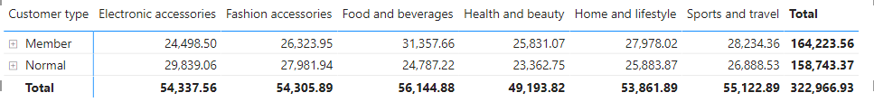

From the above table, Members of the supermarket spent most on Food and Beverages ($31,357.66) while Normal members spent the most on Electronic and Accessories ($29,839.06).

**Forecasting Sales**

Below you will find the forecast of sales for the next two weeks based on the last 3 months of sales data for each branch.

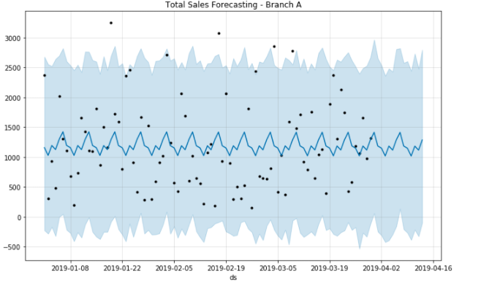

Above is the sales forecast for the Boston branch, sales are anticipated to fall over the course of the first week of April 2019 but see a rise in the second week. Over this time, daily sales are projected to be around $1,193 totaling $16,713.

Above is the sales forecast for the Denver branch, sales are anticipated to fall over the course of the first week of April 2019 but see a rise in the second week. Over this time, daily sales are projected to be around $1,100 totaling $15,427.

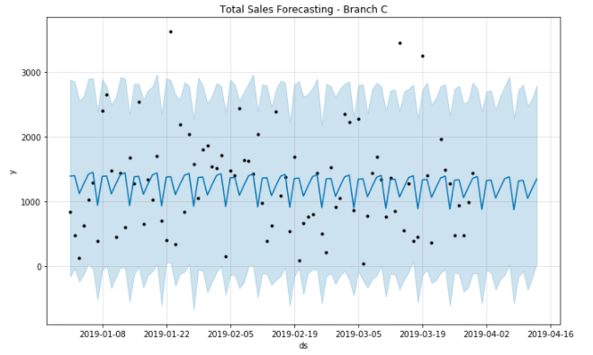

Above is the sales forecast for the Chicago branch, sales are anticipated to fall over the course of the first week of April 2019 but see a rise in the second week. Over this time, daily sales are projected to be around $1,215 totaling $17,012.

After running this forecast, this supermarket can anticipate Chicago continuing to generate the most sales over the next two weeks. However, the Boston branch is expected to outperform the Denver branch $16,713 in total sales for Boston vs. $15,427 for the Denver branch.

Appendix

All branches sales

Boston Branch Sales

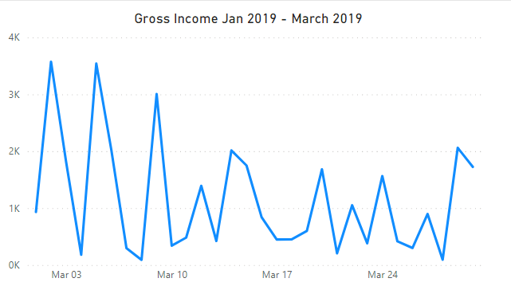

Chicago Branch Sales

Denver Branch Sales

